Dear _____________:

Thank you for choosing the Dent Neurologic Institute, Western New York's premier Neurologic and Diagnostic Center. Your upcoming appointment is scheduled with , on at . This appointment is for our office located at , , , .

Patients are required to arrive 30 minutes prior to their appointment time for the initial consultation. This time will be used to complete the registration process. Thank you for your understanding!

In order to ensure a positive experience, please be prepared with the following items on the day of your visit. Failure to comply may result in our need to reschedule your visit.
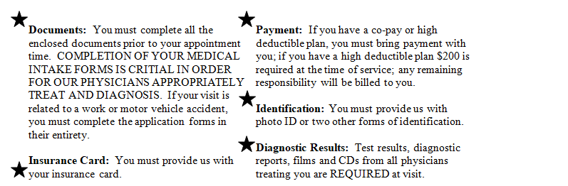
Be sure to visit our website at "http://www.dentinstitute.com" for insurances we accept and access to your on-line secured medical record.

Once again, thank you for choosing the Dent Neurologic Institute. If you have any questions, please feel free to call our Center at 716-250-2000.

Advance Notice is Required for all Cancellations
If you fail to cancel an appointment at least one business day prior; or you do not show for your scheduled appointment, you will be assessed a non-timely cancellation fee.
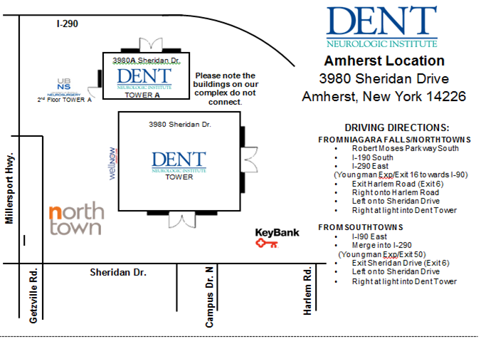
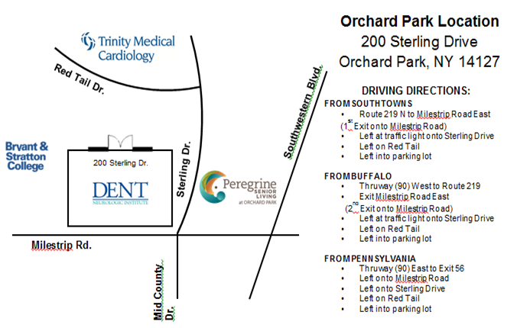

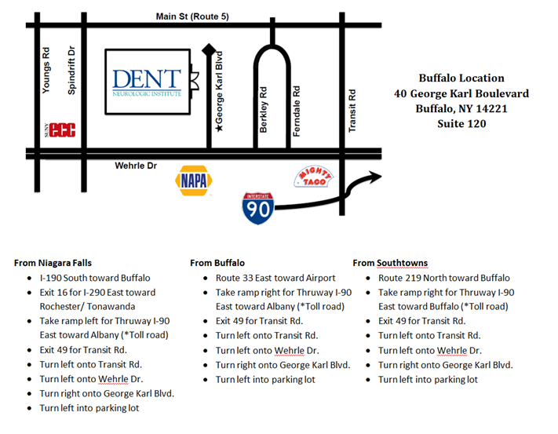

(Page Intentionally Left Blank)

DENT NEUROLOGIC
NEW PATIENT HISTORY FORM

Today’s Date ________________

Name: DOB: Age:

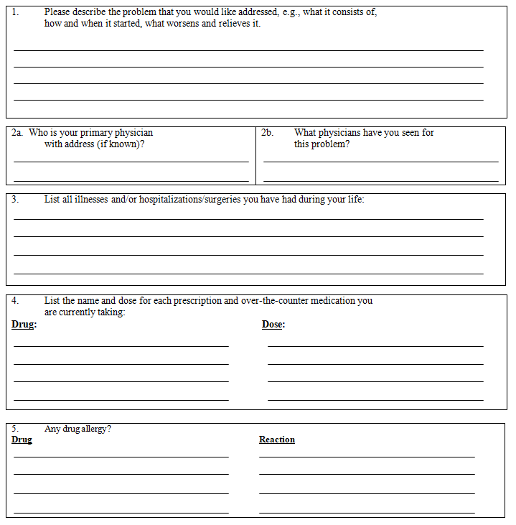
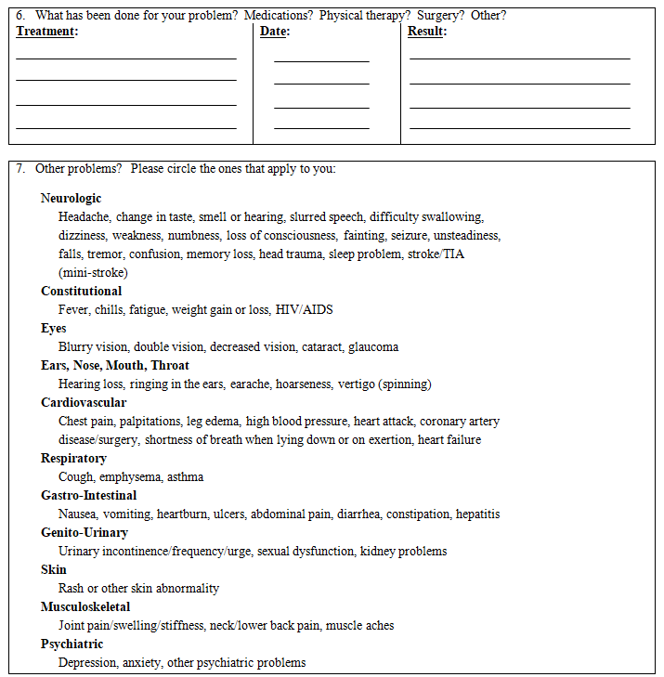
Print Name:
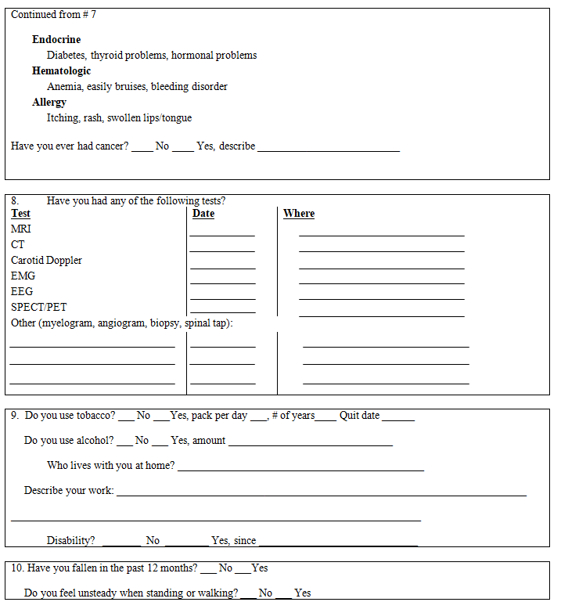
Print Name:
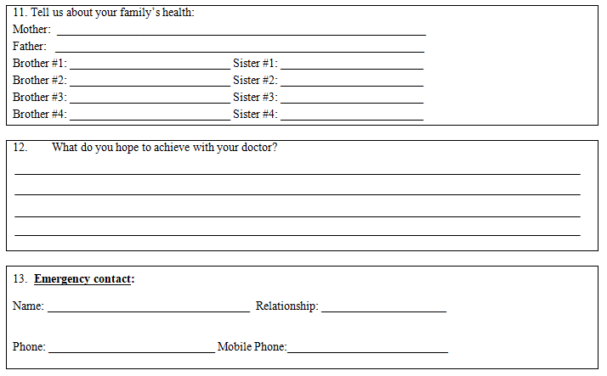

Print Name

____________________________________________ _______________________
Signature Date

Tell Us How We’re Doing!
Visit Our Website at "http://www.dentinstitute.com" and take our online survey

For office use only:

BP Pulse _________ Resp. ________ Wt. _______ Ht. _______

Headache History & Profile Questionnaire

Name: DOB: Date: ____________

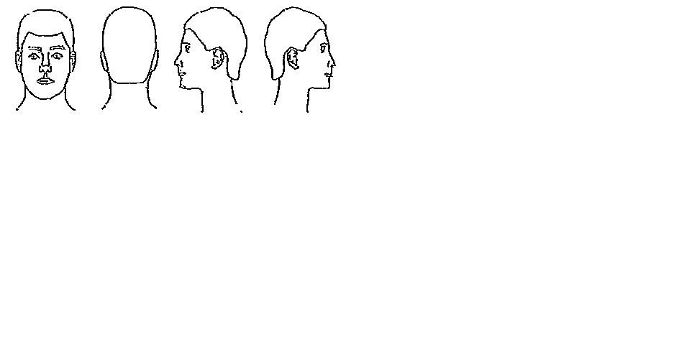
1. On what part of the head does the headache start? Circle all that apply and use the diagram to shade areas of pain:

R-Side L-Side Either Side Both Sides

Back Top Temples Behind/Around eyes

Forehead Face Neck Other
2. How long ago did the current headaches start? ____ Weeks ____ Months _____ Years
3. How old were you when any headache started? ____
4. How long does the headache usually last: ____ Minutes ____ Hours _____ Days _____Constant
5. How often does the headache occur? _____x/Day ____x/Week _____x/Mo ____x/Year _____Constant
6. Is the headache getting: □ more severe □ more frequent □ both
7. After the headache starts does it: □ stay in one place □ move around Explain:

8. How would you describe the pain?
□ throbbing/pulsating □ pressing/squeezing □ stabbing □ sharp □ dull/nagging □ other:
9. On a scale of 1 to 10, describe the degree of pain when:
Your headache starts: 1 2 3 4 5 6 7 8 9 10

With most of your headaches: 1 2 3 4 5 6 7 8 9 10

With your worst headache: 1 2 3 4 5 6 7 8 9 10
10. Do your headaches prevent normal activities such as work, school, etc? □ yes □ no
12. Has productivity at work or school been affected by your headaches? □ yes □ no
13. In the last month has your headaches caused you to miss leisure activities/work/school? □ yes □ no
14. In the last 6-months, has your headaches caused you to miss leisure activities/work/school? □ yes □ no
15. Do any blood relatives have severe headaches: □ yes □ no If yes, who & diagnosis:
16. Do any have history of head or neck injury? □ yes □ no
17. If yes, did this involve a loss of consciousness? □ yes □ no
18. Which of the following makes the headache better (circle all that apply):

Rest Activity Darkness Quiet Cold Compresses Hot Compress Scalp/temple pressure
19. Do you exercise regularly? □ yes □ no If yes, how often and what:
20. Do you frequently skip meals? □ yes □ no
21. How much caffeine do you eat/drink in a day? (i.e. coffee, tea, soda, chocolate)
22. Social History: Cigarettes (#day/#yrs) ___/___ Coffee (cups/day) ___/___
23. Do you have any problems sleeping? □ yes □ no
24. Does the headache awaken you from sleep? □ yes □ no
25. Do you awake feeling rested? □ yes □ no
26. Are you or have you been depressed or anxious? □ yes □ no

Associated Headache Symptoms:

Are any of the following symptoms associated with the headache? Please mark: (B) Before (X) During (A) After
FACE AND SCALP:  ____ Spots before eyes R/L  ____ Blindness R/L  ____ Blurring R/L  ____ Eyelid Droop R/L  ____ Tearing R/L  ____ Double Vision R/L  ____ Eye Redness R/L  ____ Eyes Puffy R/L  ____ See only half objects R/L  ____ Noise Sensitivity  ____ Odor Sensitivity  ____ Light Sensitivity  ____ Nose Discharge R/L  ____ Nose Blocked R/L  ____ Paleness  ____ Redness  ____ Sweating  ____ Tenderness  ____ Pain on chewing  ____ Puffiness  ____ Decreased jaw opening  PLEASE MARK IF YOU EXPERIENCE:  (W) Weakness (N) Numbness (B) Both  ____ Face R/L  ____ Arms R/L  ____ Legs R/L  ____ Arm and Leg R/L  ____ Numbness around Lips |  | GENERAL:  ____ Nausea  ____ Vomiting  ____ Stomach Cramps  ____ Hunger  ____ Loss of Appetite  ____ Diarrhea  ____ Depression  ____ Fatigue  ____ Anxiety  ____ Irritability  ____ Difficulty concentrating  ____ Difficulty talking or finding words  ____ Difficulty understanding  ____ Fainting or feel like fainting  ____ Slurred speech  ____ Dizziness  NECK:  ____ Stiffness  ____ Tenderness  HANDS AND/OR FEET:  ____ Cold  ____ Pale  ____ Sweaty  ____ Mottled
Indicate if any of the following factors have (+) Brought on (trigger) or (++) Worsened your headache:
____ Sleep too much or little  ____ Emotional stress  ____ Depression - anxiety  ____ Physical Activity  ____ Erect Position  ____ Bending Over | ____ Missed Meal  ____ Change in Weather  ____ Seasons  ____ Processed Meats  ____ Chocolate  ____ Citrus Fruits | ____ Cheese  ____ MSG  ____ Other foods (list)  ____ Straining/Coughing  ____ Menstrual Periods  ____ Oral Contraceptives | ____ Medications (list)  Menstrual Periods  ____ Pregnancy  ____ Menopause  ____ Oral Contraceptives

Patient Name:

What is Chronic Migraine?
Chronic Migraine is a condition defined as 15 or more headache days a month with each
headache lasting 4 hours or more per day. At least of half of the headaches should be migraine.
How to use this screener:
The following questions can help you and your physician understand your condition and help
determine if you have Chronic Migraine. Being thorough about your headaches/migraines will
help your physician determine how much of your headaches affect your daily life and help get
you to a more accurate diagnosis and find treatment options that are right for you.

Personal Information

Name:

Date of Birth:

Important information before you get started

What are headache days?

It is important to understand the number of days you had headaches (including migraines) rather than the number of attacks.
- For example, you have a headache that starts on Monday and does not go away until Wednesday; it may be one attack, but that is considered 3 headache days
Remember to provider your doctor with an accuration number of ALL of the days you experience pain of any kind.

Are migraine days the same as headache days?
Some of your headaches may be a type of headache known as migraine. If you experience any combination of the following symptoms, your headache may be a migraine:
- Constant, throbbing pain felt on one side of the head (but can be on both sides)
- Sensitivity to light and sound

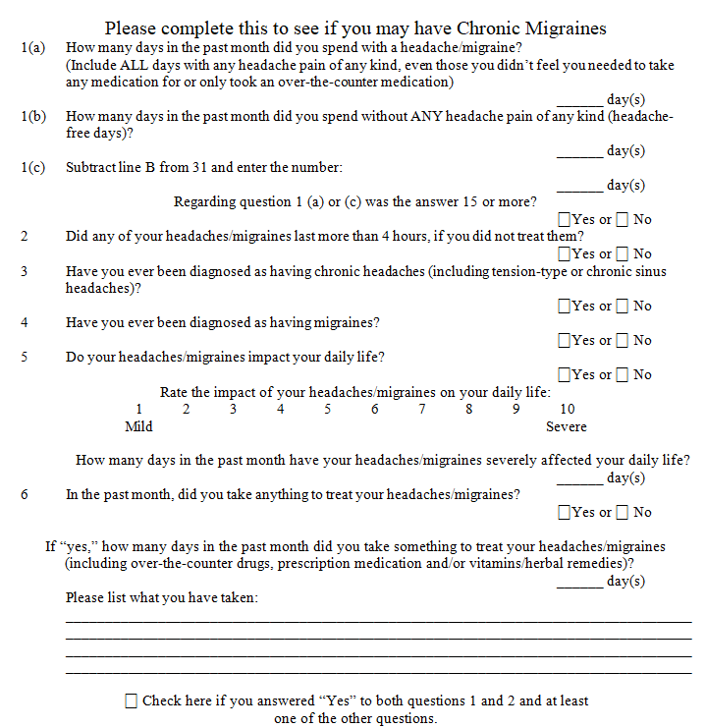

Patient Name:
Patient Name: D.O.B: Date: _______________


Adult MIDAS (18 years of age and older)

The MIDAS (migraine disability assessment) questionnaire was put together to help you measure the impact your headaches have on your life over the last 3 months and to communicate this more effectively. The best way to this is by counting the numbers of days of your life which are affected by Headaches.INSTRUCTIONS • Please answers the following questions about ALL your headaches you have had over the last 3 months. Select your answer in the box next to each question. If a single headache affects more than one area of your life (e.g., work and family life) it is counted more than once. Select zero if you did not have the activity in the last 3 months. There are no “right” or “wrong” answers so please put down your best guess.
For questions 1 and 2, work or school means paid work or education if you are a student at school or college. For Questions 3 and 4, household work means activities such as housework, home repairs and maintenance, shopping as well as caring for children and relatives.
- On how many days in the last 3 months did you miss work or school because your headaches?
- How many days in the last 3 months was your productivity at work or school reduced by half or more because of your headaches?
(Do not include days you counted in question 1 where you missed work or school.)
- On how many days in the last 3 months did you not do household work because of your headaches?
- How many days in the last three months was your productivity in household work reduced by half of more because of your headaches?
(Do not include days you counted in question 3 where you did not do household work.)

Patient Name: D.O.B:
- On how many days in the last 3 months did you miss family, social or leisure activities because of your headaches?

Enter the total number of days you entered in questions 1-5. This is your
MIDAS level of disability.
Total
0 to 5 - MIDAS Grade I, Little or no disability

6 to 10 - MIDAS Grade II, Mild disability

11 to 20 - MIDAS Grade III, Moderate disability

21+ - MIDAS Grade IV, Severe disability

That Your Physician will need to know about your headache:
- On how many days in the last 3 months did you have a headache?
(If a headache lasted more than 1 day, count each day.)
- On a scale of 0 - 10, on average how painful were these headaches?
(Where 0 = no pain at all and 10 = pain as bad as it can be.)

